HOTEL BOOKING
Submitted for

BUSINESS FORECASTING METHODS AND APPLICATIONS

Submitted by:
(502304199) JASMON KAUR
(502304213) VARUN SINGH

Submitted to-
Dr. Nitin Arvind Shelke


L M Thapar School of Management

Jan-May 2024

INDEX

Sr No
Content | Page No

LIST OF FIGURES

Figure No. | Title | Page No.
2.1 | Block diagram | 12

LIST OF TABLES

Table No. | Title | Page No.
1.1 |  | 8

Note: List of Figures and List of Tables shall be on separate pages.

- ABSTRACT
This study focuses on the rising issue of hotel reservation cancellations, especially in City and Resort Hotels. It aims to:
- Identify the reasons behind cancellations
- Offer practical solutions to improve revenue
.
- INTRODUCTION AND RELATED WORK
The hospitality industry has been facing a major challenge of high cancellation rates which result in lower room occupancy and lost revenue. This issue is particularly concerning for City Hotels and Resort Hotels. The focus of this study is to identify the factors that drive guest cancellations and other relevant variables that impact revenue generation for these two types of establishments. By analyzing these factors, we aim to provide actionable recommendations that can help City and Resort Hotels improve their operational efficiency and maximize their revenue potential.

- SOFTWARE USED
The software used is juypter notebook

- METHODOLOGY --- Flowchart
HOTELS

RESORT HOTEL
CITY HOTEL

BOOKING STATUS

NON-CANCELLATION
CANCELLATION

- EXPERIMENTAL RESULTS
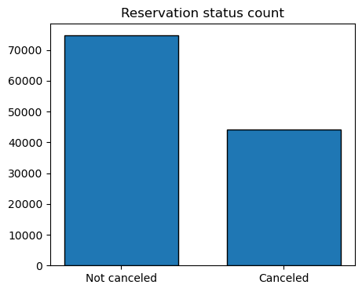
The bar graph provided displays the percentage of reservations that have been canceled and the ones that have not been canceled. A considerable number of reservations are still active. However, 37% of clients have canceled their reservations, which is having a significant impact on the earnings of the hotels.

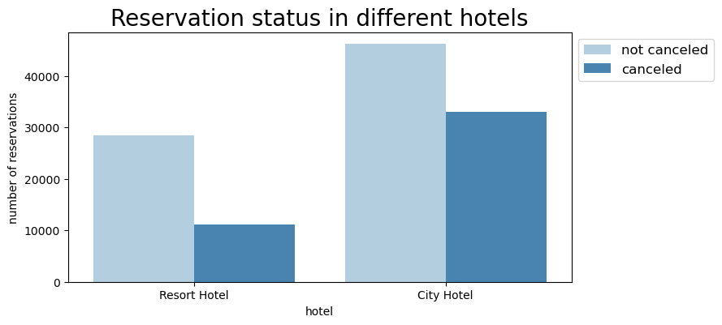
In comparison to resort hotels, city hotels have more bookings. Resort hotels may be more expensive than those in cities.
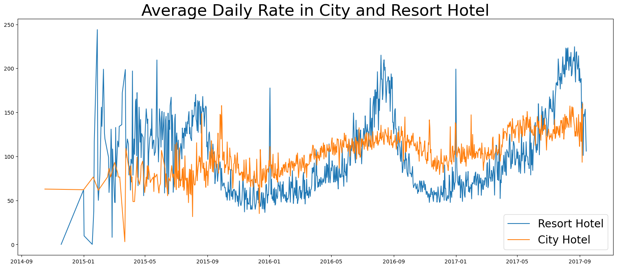
The line graph depicted above illustrates that the average daily rate for a city hotel is lower than that of a resort hotel on some days and even lower on other days. It's important to note that the rates for resort hotels may rise during weekends and holidays.

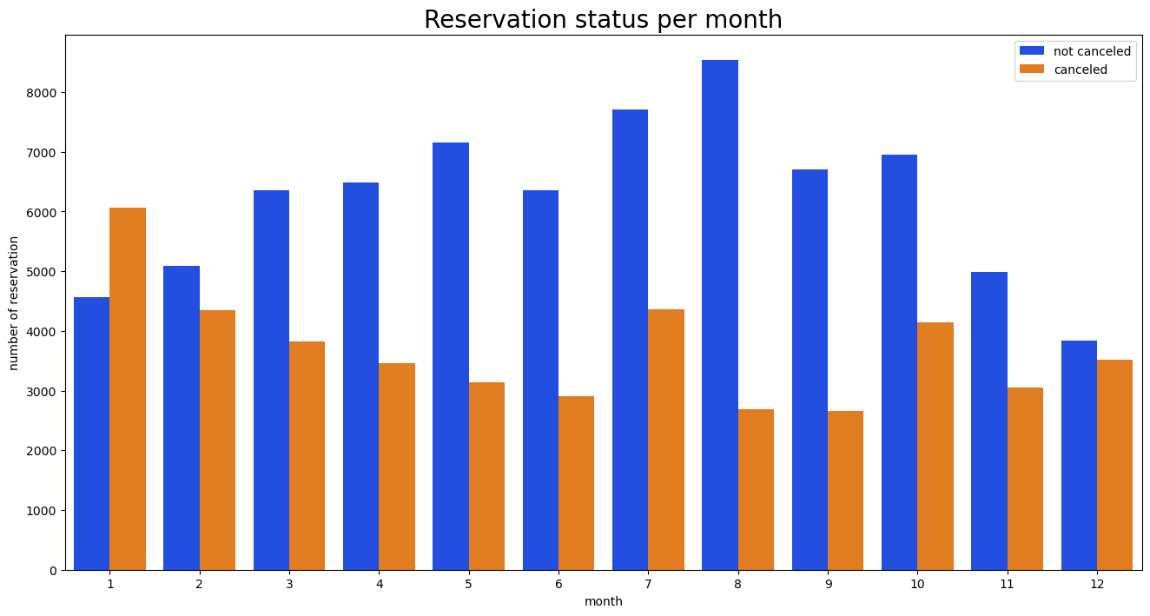

We have created a grouped bar graph to analyze the reservation levels for each month based on the reservation status. The graph clearly shows that the highest number of confirmed reservations and canceled reservations occurred in August. On the other hand, January had the highest number of canceled reservations.

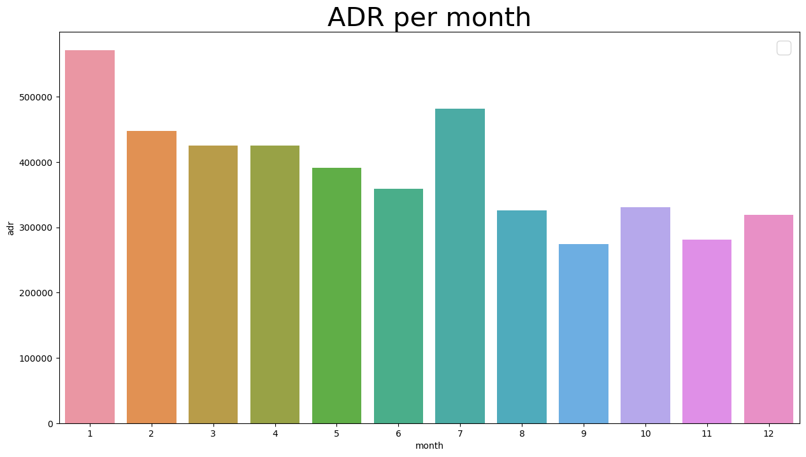
This bar graph shows that cancellations tend to occur more frequently when accommodation prices are higher and less frequently when they are lower. Therefore, it seems that the cost of the accommodation is the main reason for cancellations.
Now, let's find out which country has the highest number of cancelled reservations. According to the data, Portugal has the highest number of cancellations.

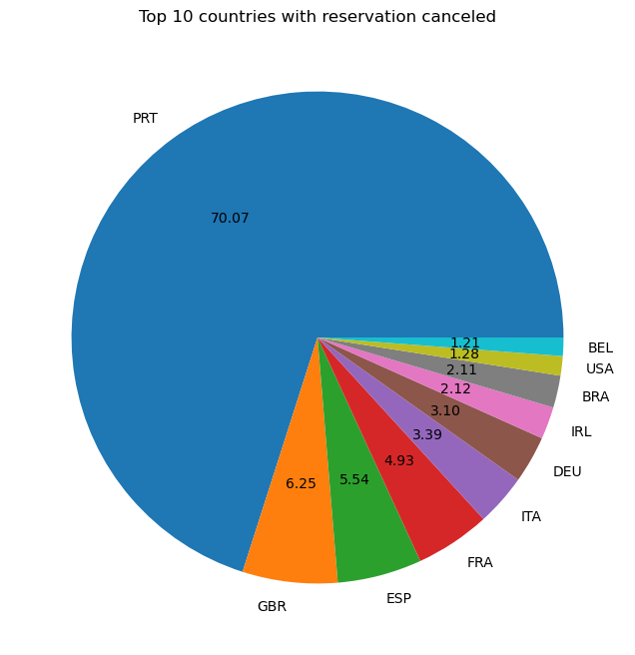

Around 46% of clients come from online travel agencies, whereas 27% come from groups. Only 4% of clients book hotels directly by visiting them and making reservations.

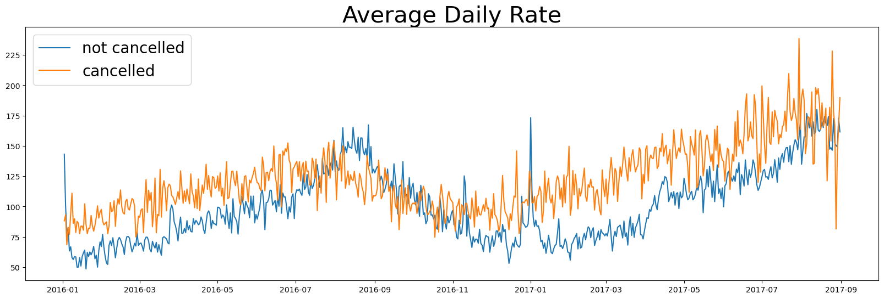
In the line graph, reservations are cancelled when the average daily rate is higher than when it is not cancelled. It proves all the above analysis, that a higher price leads to higher cancellations.
- CONCLUSION
Cancellation rates rise as the price does. The ratio of the cancellation of the resort hotel is higher in the resort hotel than in the city hotels. In January, hotels can start campaigns or marketing with a reasonable amount to increase their revenues as the cancellation is the highest in this month. They can also increase the quality of their hotels and their services mainly in Portugal to reduce the cancellation rate.
- REFERENCES
Dataset: Kaggle

- GitHub Repository Link

